#include <string>

#include <cctype>

getline(cin>>ws,s);

char s[1000];

cin.get(s,1000);

can’t use after integer

char s[100];

cin.get(s, 100, '\n');

can’t use after integer

sizeof(s)

#include <string>

#include <cctype>

s1[i] = tolower(s1[i]);

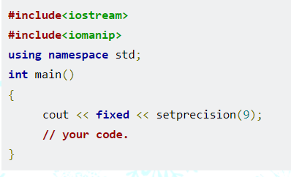

cout << "floor " << n << "/" << m << " = " << int(n/m) << endl;

int a[5];

cout << a[0] << " " << a[2] << endl;

vector pair:

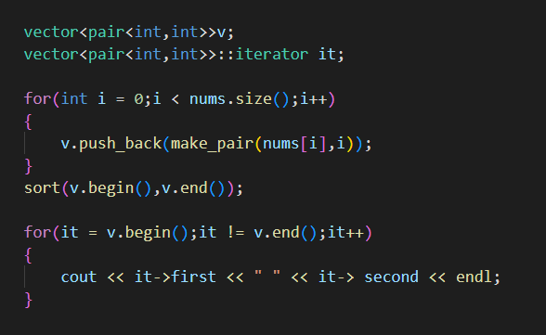

## Converting Number to String in C++

* **Using string Stream**
* **Using to_string()**
* **Using boost lexical cast**

**Time Complexity:**O(n)

**Auxiliary Space:**O(n)

## Uppercaseprint:

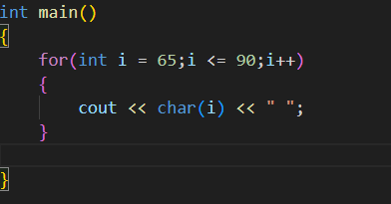

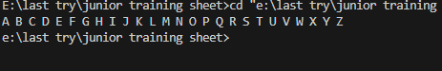

## Lowercaseprint:

